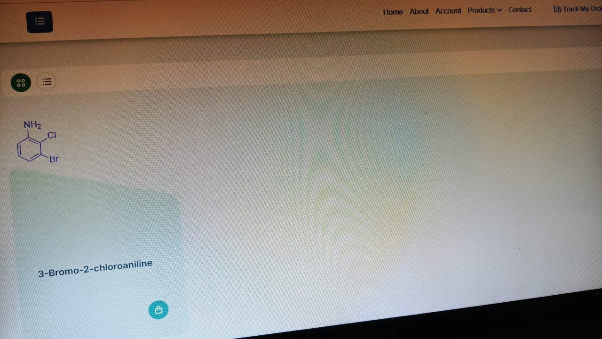
Now we added one product to the list. But it is in frontend all details are showing in 2 step process
With single search we need all details at frontend
Like BLD PHARM WEBSITE
Here in admin dash board the size of test box should be reduced and gap between all items should be minimized

JMC PHARMA size should be increased and and text below need to reduce and content and back ground need to be changed
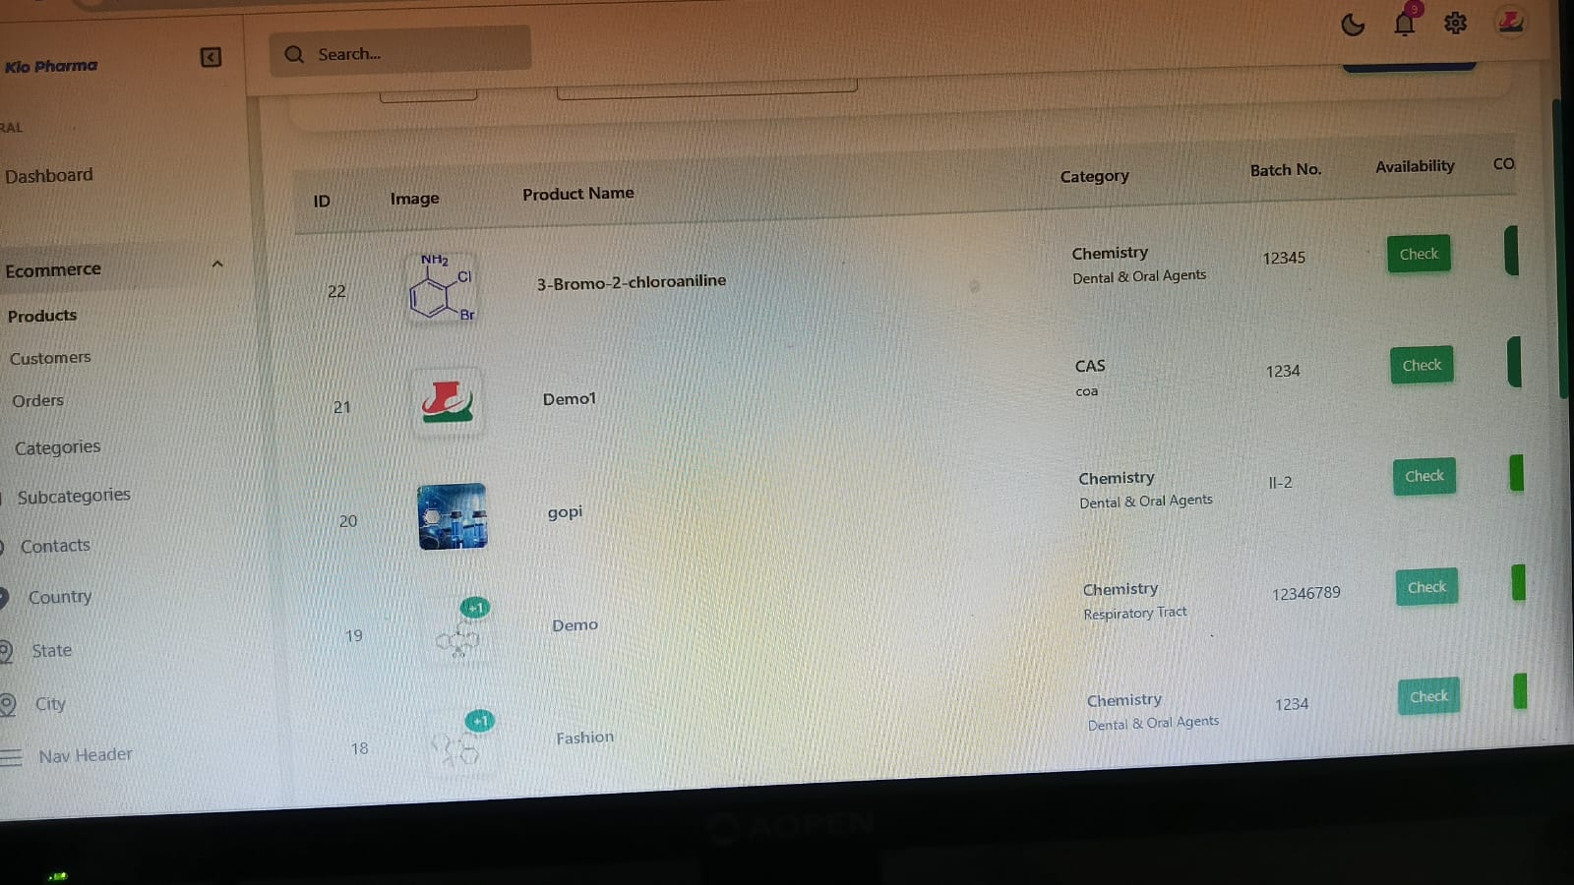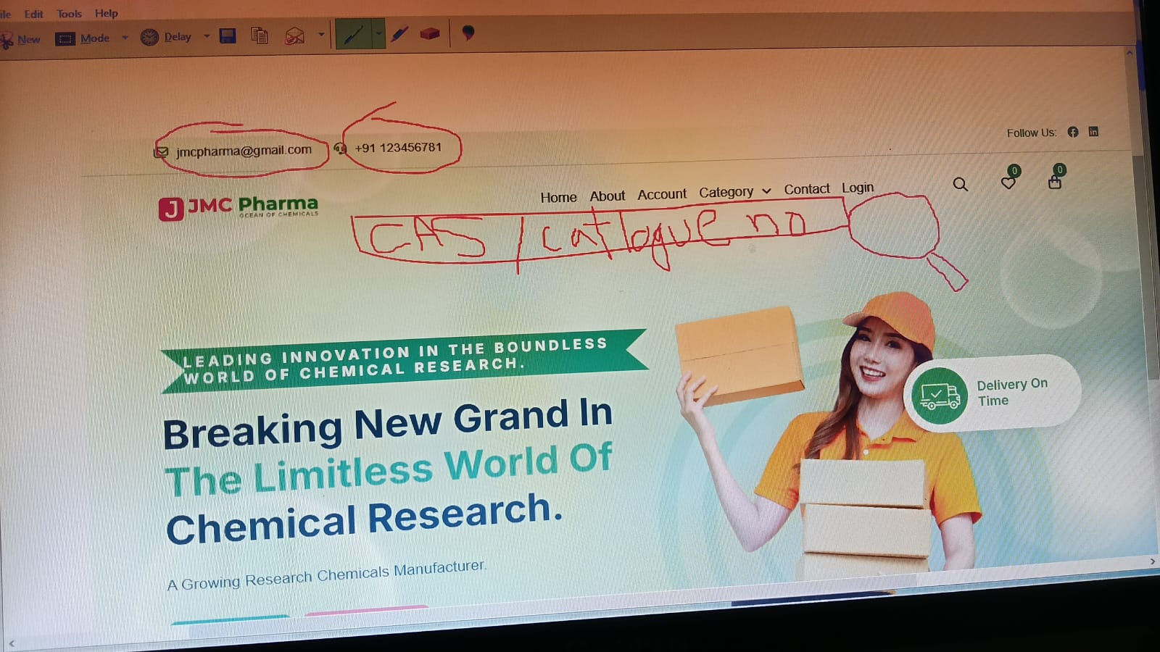
Synchronize the page
Here search is not working by giving cas no and product name
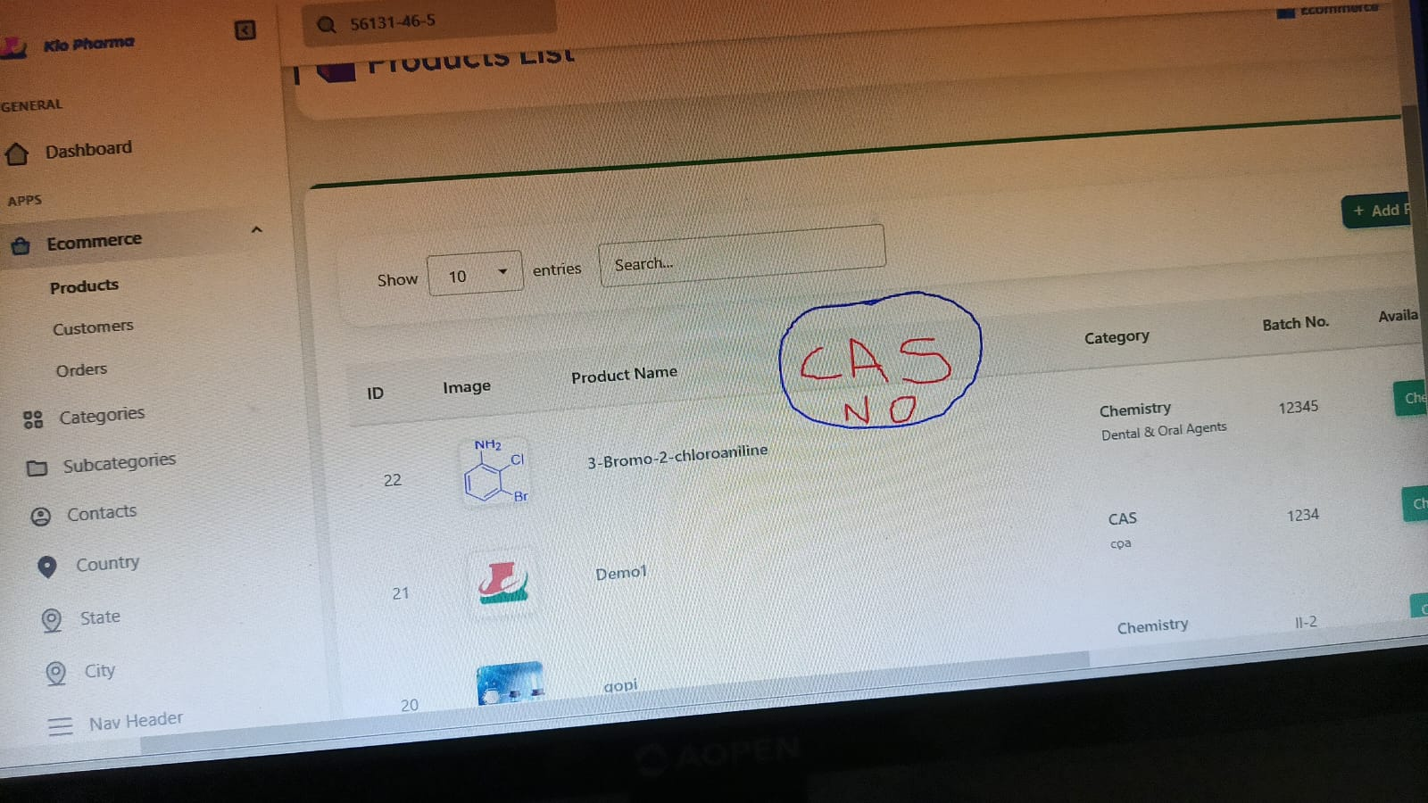
Cas no column should be added and add scroll bar or synchronize the page or all
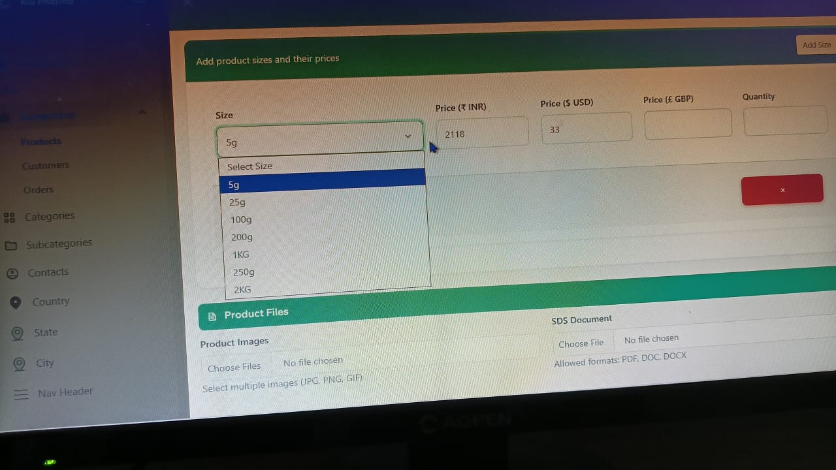
Please customize the drop down bcs we need to add other sizes like 100mg , 250mg 1gm. Etc upto 1 kg
In the size category in all the cases should be customize like above
Gap between line should be reduced
Like highlighted 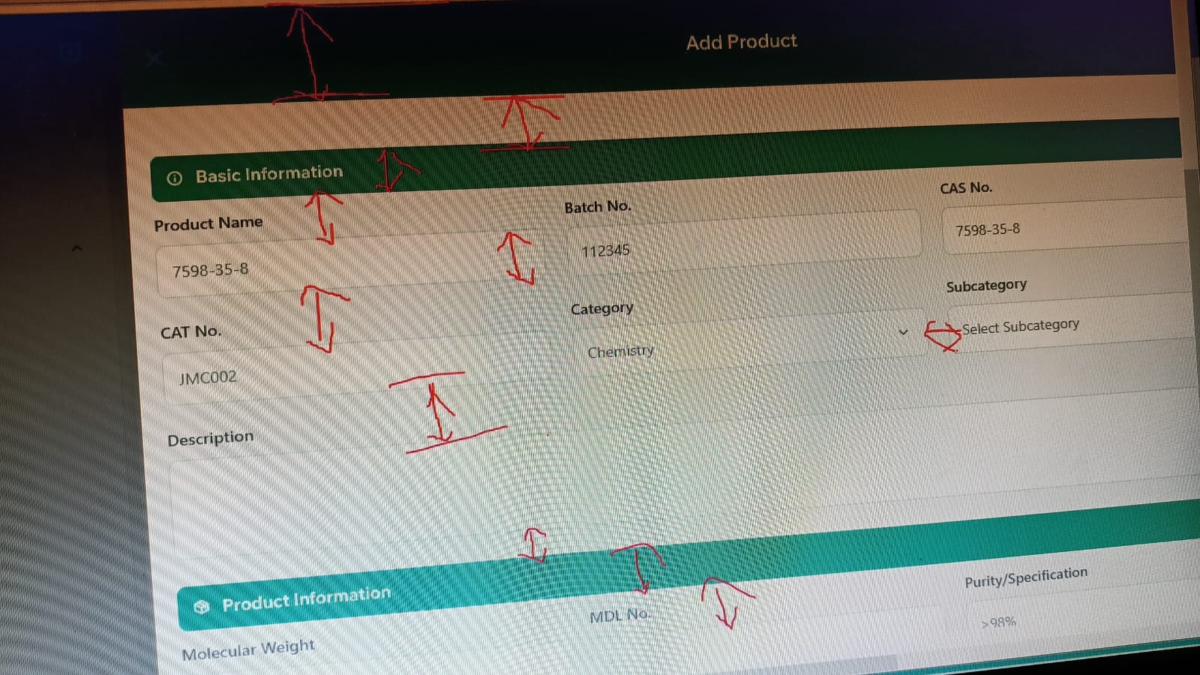
above in all the cases minimize the space and scroll bars should apper
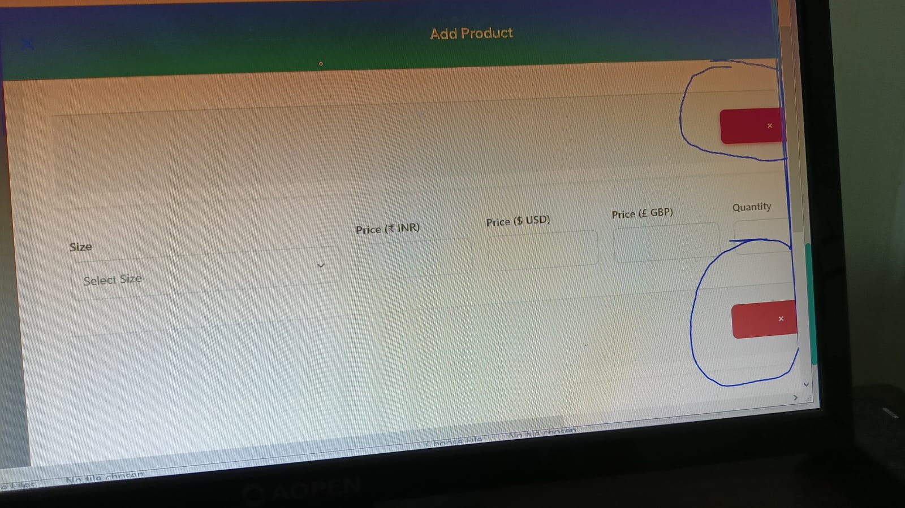Not able to delete and give delete option. Put Scroll bar
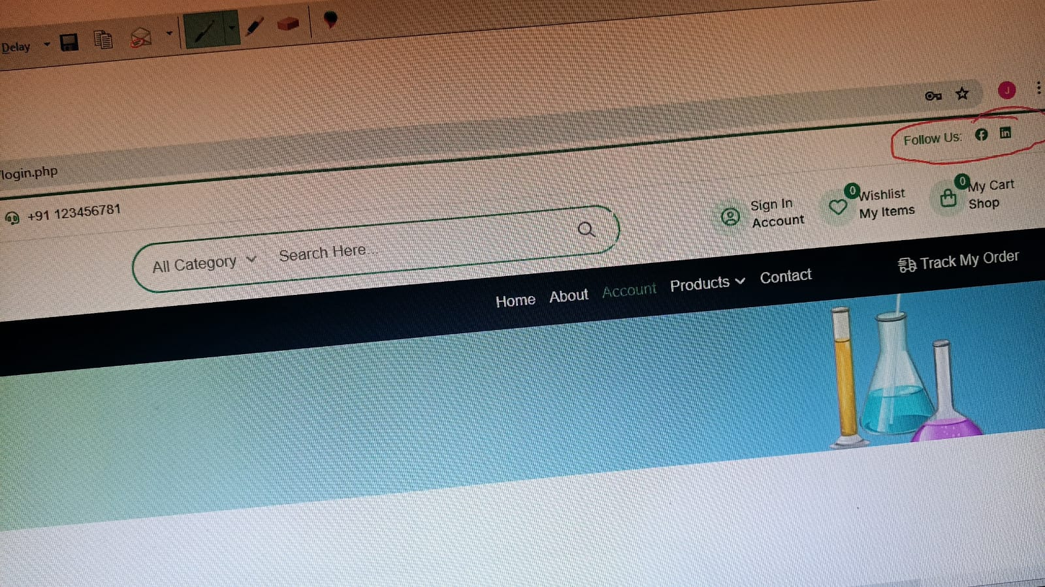
Increase the sizes in red highlighted
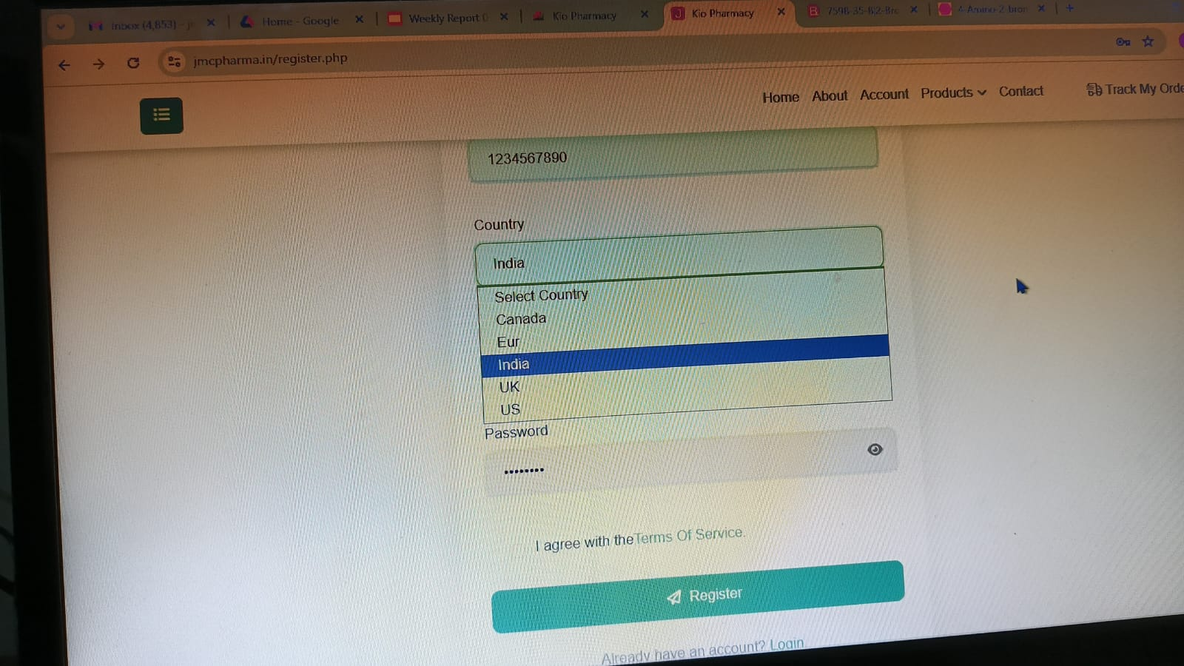
Country entry should be customised because
Front end customer registration
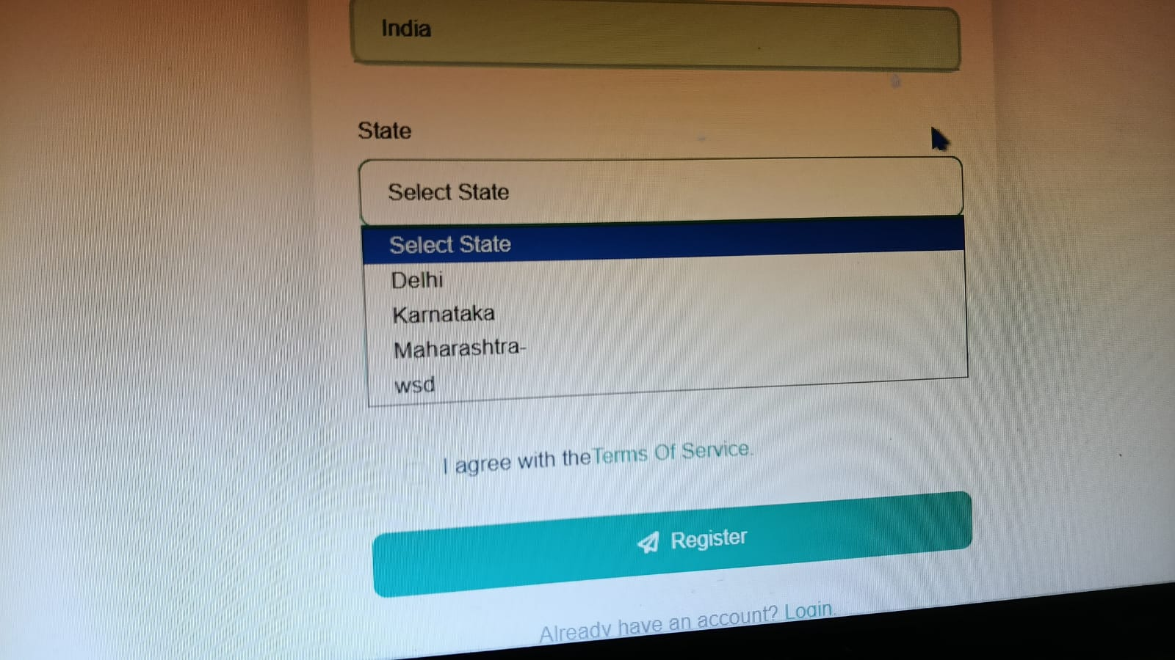
State also should be customised
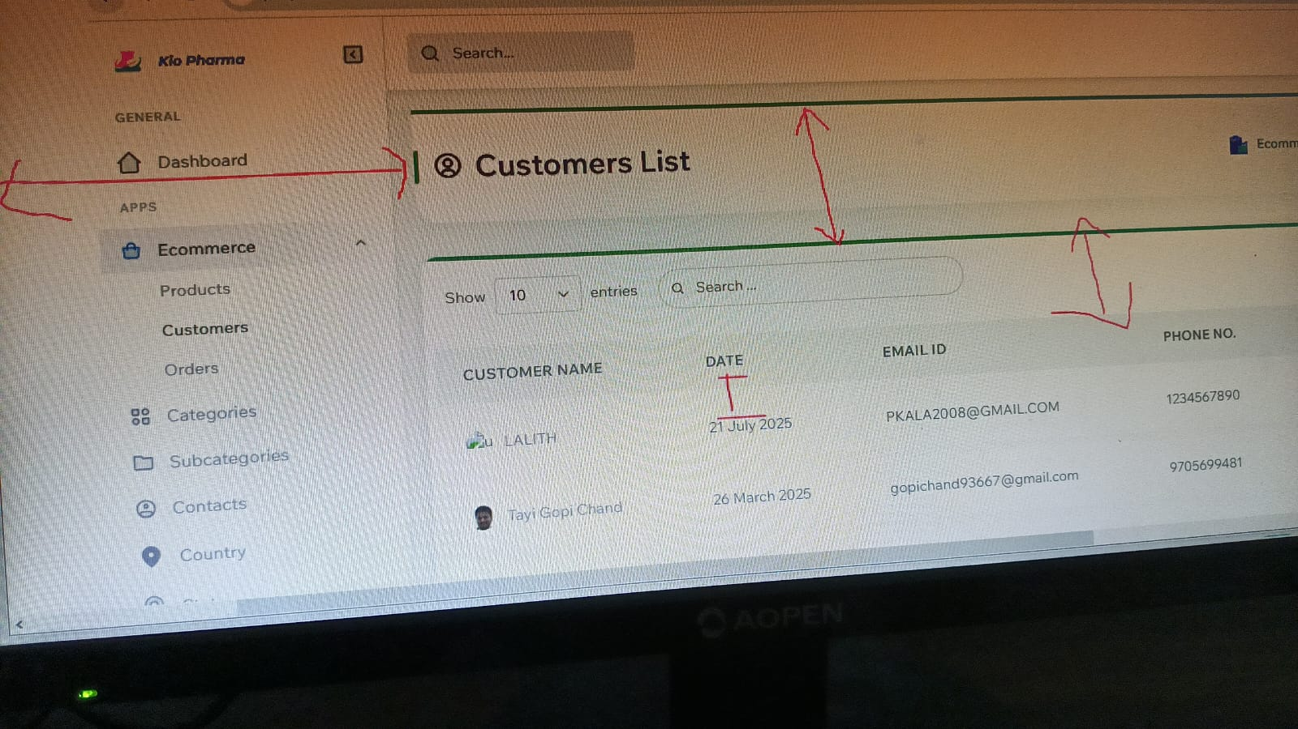
Reduce space in all the cases not only at hilighted places
Invoice

JMC PHARMA PVT LTD,
JMC Pharma Pvt Ltd,
# 9-13 Room No-6,
Isnapur, IDA Pashamylaram,
Patancheruvu, Medak-502307,
Telangana, India

